

**Faculty of engineering - Shoubra**

**Benha University**

**Research Article**

|  |  |
| --- | --- |
| **Department** | **Engineering Mathematics and Physics** |
| **Division** | **----------** |
| **Academic Year** | **2019-2020 Preparatory** |
| **Course name** | **Computer** |
| **Course code** | **ECE006** |

**Title: -**

**Artificial Intelligence**

By:

|  |  |  |  |
| --- | --- | --- | --- |
|  | Name | Edu mail | B.N |
| 1 | سيد محمد سيد حسين | [Said195455@feng.bu](mailto:Said195455@feng.bu).edu.eg | 408 |

**Approved by:**

|  |  |
| --- | --- |
| Examiners committee | Signature |
| Dr. Ahmed Bayoumi |  |
| Dr. Shady Elmashad |  |
| Dr. Abdelhamid Attaby |  |

**Abstract**

|  |
| --- |
|  |
| Artificial Intelligence (A.I.) is a multidisciplinary field whose goal is to automate activities that presently require human intelligence. Recent successes in A.I. include computerized medical diagnosticians and systems that automatically customize hardware to particular user requirements. The major problem areas addressed in A.I. can be summarized as Perception, Manipulation, Reasoning, Communication, and Learning. Perception is concerned with building models of the physical world from sensory input (visual, audio, etc.). Manipulation is concerned with articulating appendages (e.g., mechanical arms, locomotion devices) in order to effect a desired state in the physical world |

* **Screenshots**

1. **Website source code**

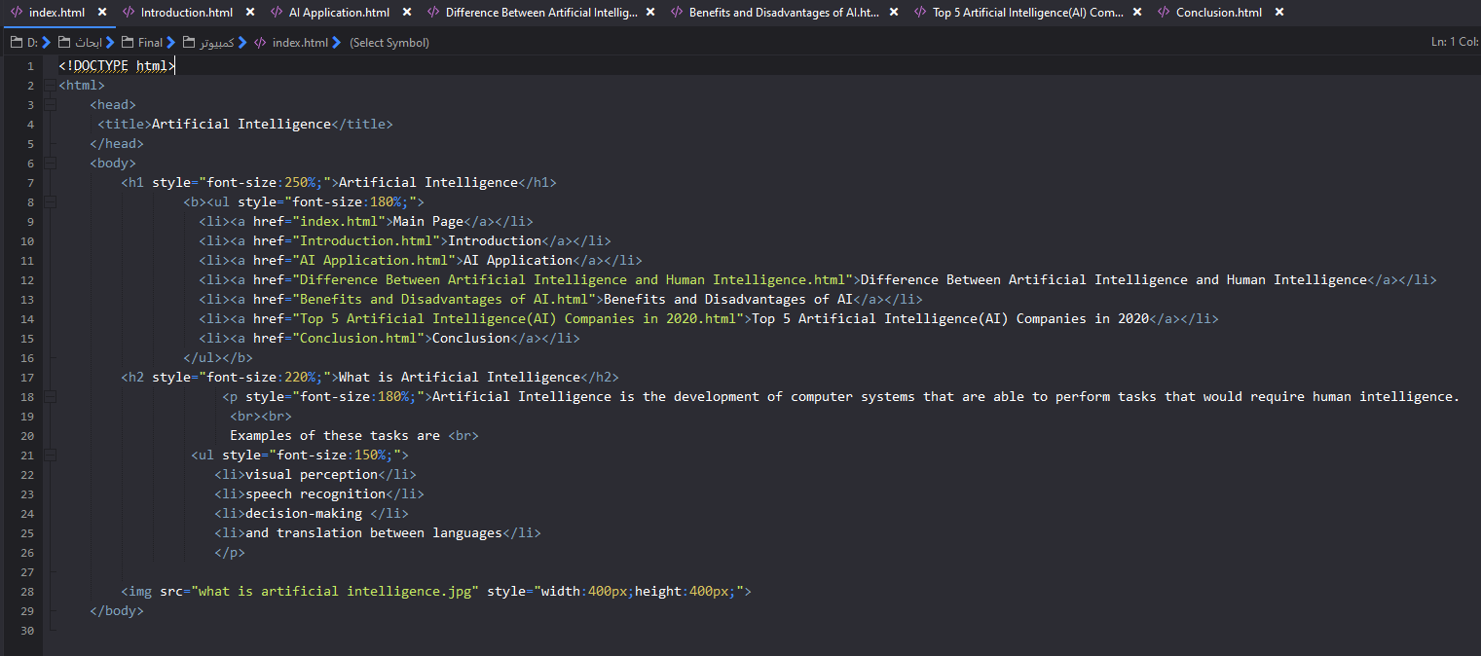

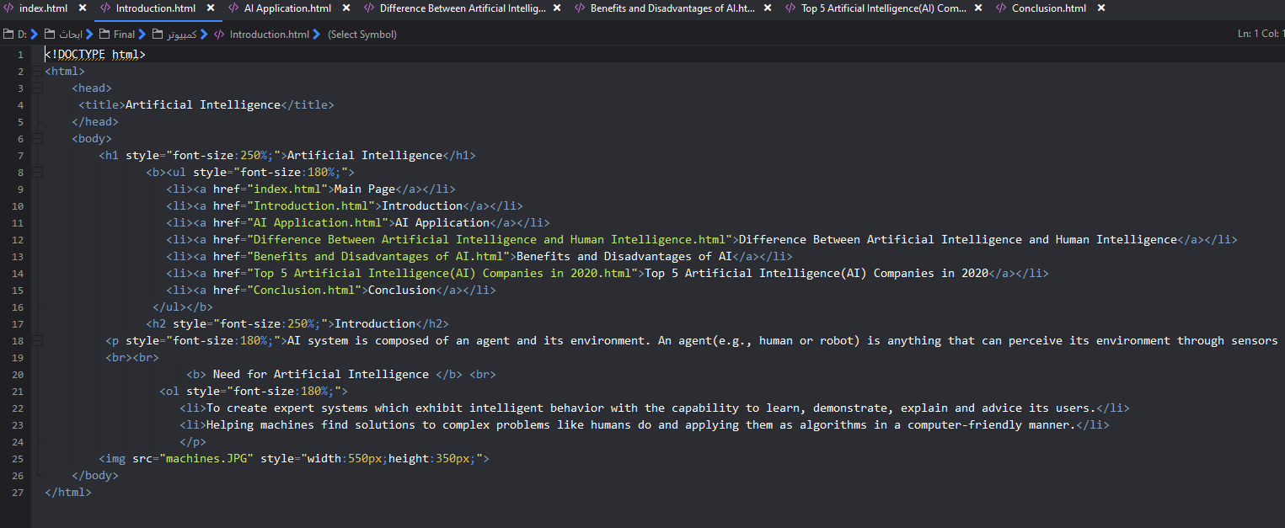

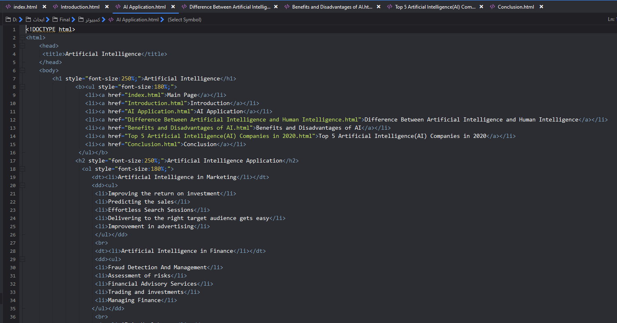

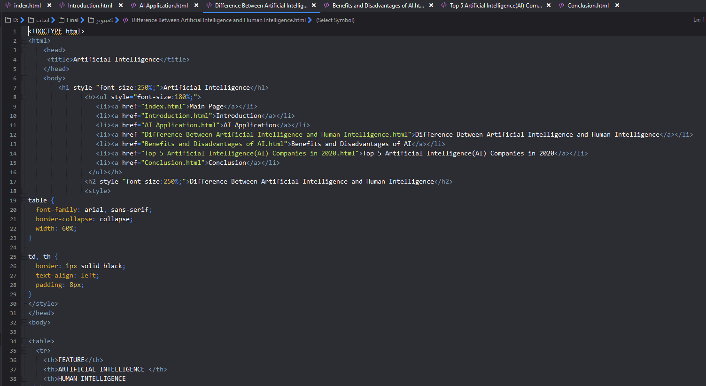

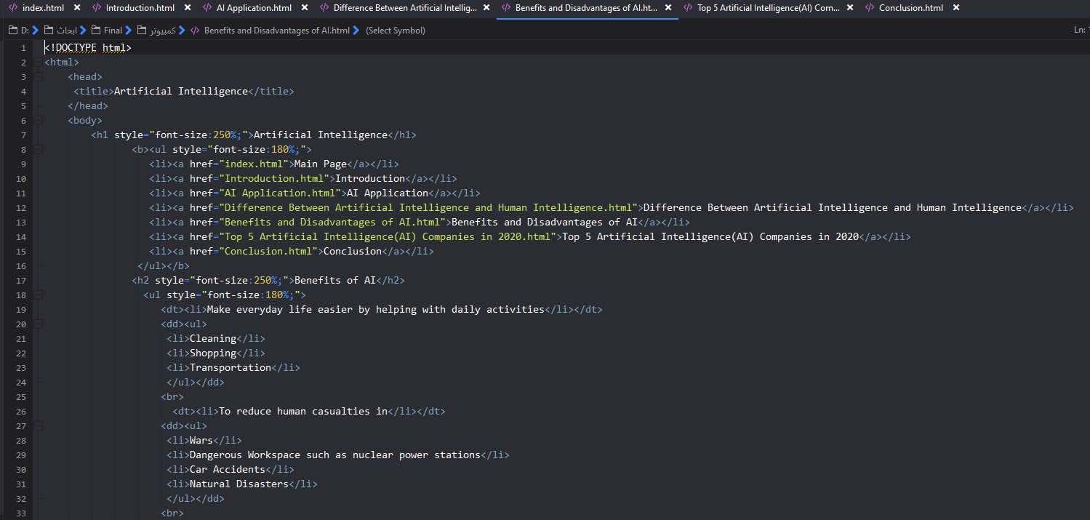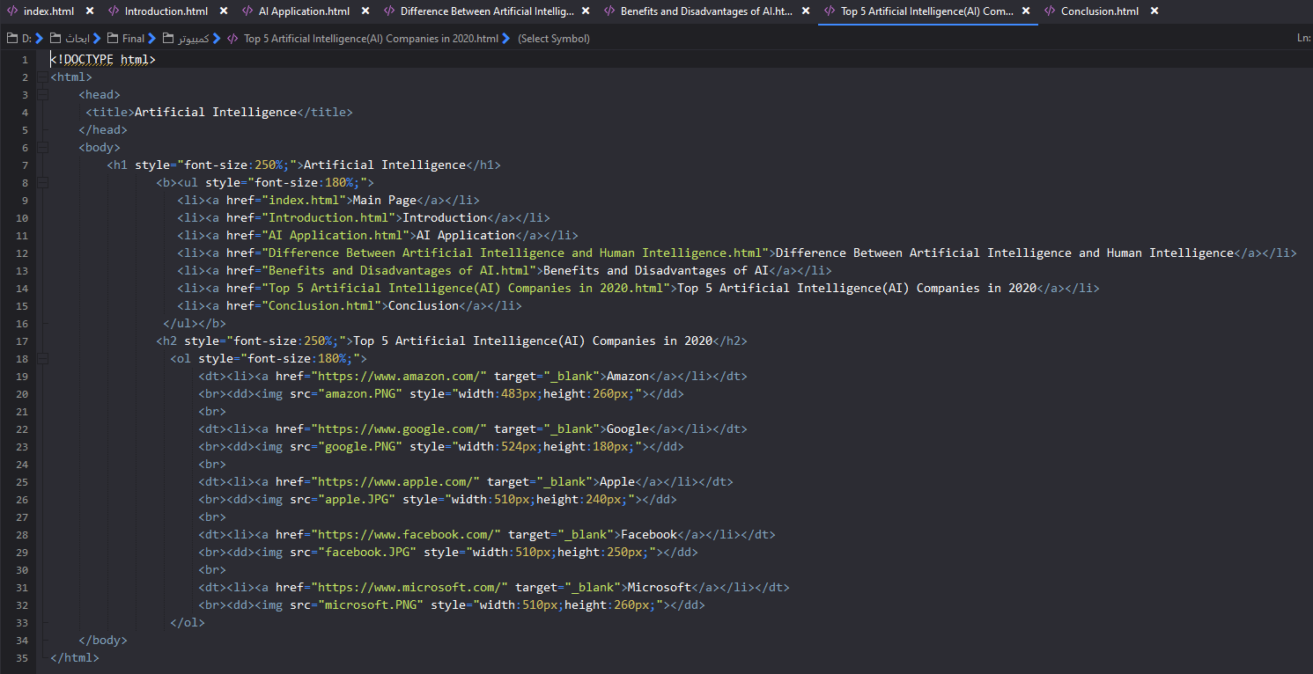

1. 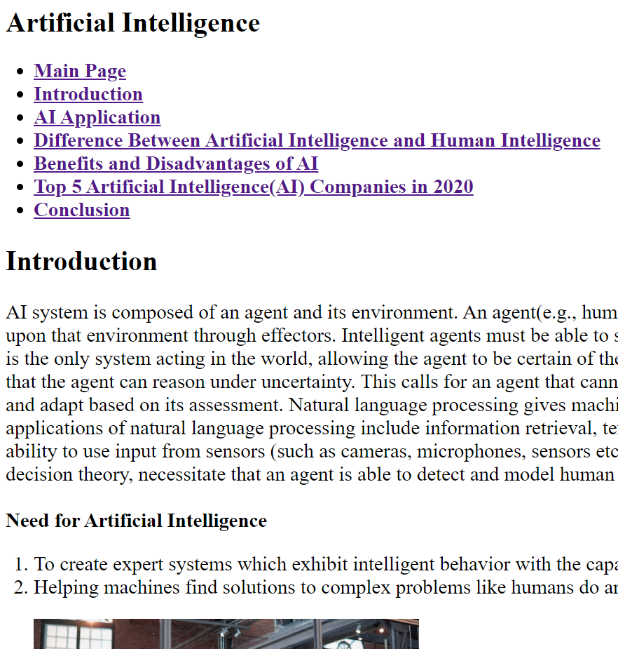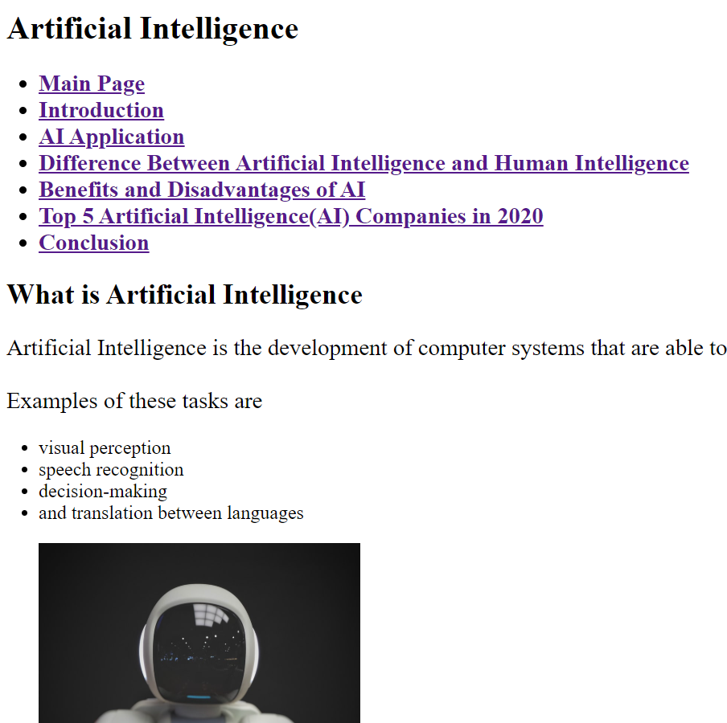**Website**

